Day 20 , Emp_Id : 112916146

Task001::
public class Student {
private String name;
private int rollNo;
private int[] marks;
private double feesPaid;

public Student(String name, int rollNo, int[] marks, double feesPaid) {
this.name = name;
this.rollNo = rollNo;
this.marks = marks;
this.feesPaid = feesPaid;
}

public void registrationDetails() {
System.out.println("----- Registration Details -----");
System.out.println("Name : " + name);
System.out.println("Roll No. : " + rollNo);
}

public void marksCalc() {
int total = 0;
for (int mark : marks) {
total += mark;
}
double average = (double) total / marks.length;
System.out.println("----- Marks Summary -----");
System.out.println("Total Marks : " + total);
System.out.println("Average Marks: " + average);
}

public void feesCalc() {
double totalFees = 50000.0;
double balance = totalFees - feesPaid;
System.out.println("----- Fees Details -----");
System.out.println("Fees Paid : ₹" + feesPaid);
System.out.println("Remaining Fees: ₹" + balance);
}
}

Task002::
A class should have only one responsibility.
class Employee {
private String name;
private String email;
private double salary;

// Getter methods and data-related logic
}
class ReportGenerator {
public void generatePdfReport(Employee employee) {
// Code to generate PDF report for the employee
}
}
class EmailSender {
public void sendEmail(Employee employee) {
// Code to send email to the employee
}
}

Task003 ::

This violates O in SOLID

Defining common interface for payment

interface PaymentMethod {
void pay(double amount);
}

class CreditCardPayment implements PaymentMethod {
public void pay(double amount) {
System.out.println("Processing credit card payment of $" + amount);
}
}

class PayPalPayment implements PaymentMethod {
public void pay(double amount) {
System.out.println("Processing PayPal payment of $" + amount);
}
}

class BitcoinPayment implements PaymentMethod {
public void pay(double amount) {
System.out.println("Processing Bitcoin payment of $" + amount);
}
}

Task004::
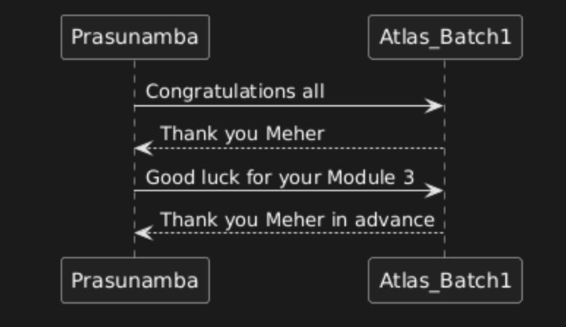

Task005::
